**Module 7 - Spring REST using Spring Boot 3**

**Create static employee list data using spring xml configuration**

**Structure:**

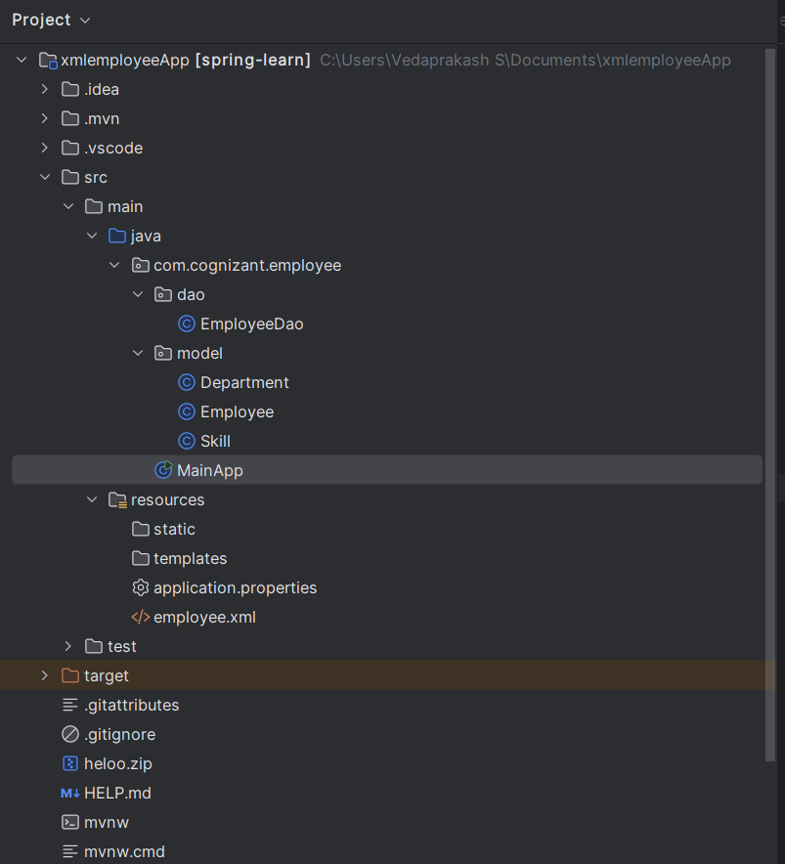

**EmployeeDao.java:**

package com.cognizant.employee.dao;  
  
import com.cognizant.employee.model.Employee;  
import org.springframework.context.ApplicationContext;  
import org.springframework.context.support.ClassPathXmlApplicationContext;  
  
import java.util.ArrayList;  
import java.util.List;  
  
public class EmployeeDao {  
  
 private static final String *XML_CONFIG* = "employee.xml";  
  
 public static ArrayList<Employee> *EMPLOYEE_LIST*;  
  
 public EmployeeDao() {  
 ApplicationContext context = new ClassPathXmlApplicationContext(*XML_CONFIG*);  
 List<Employee> list = (List<Employee>) context.getBean("employeeList");  
 *EMPLOYEE_LIST* = new ArrayList<>(list);  
 }  
  
 public List<Employee> getAllEmployees() {  
 return *EMPLOYEE_LIST*;  
 }  
}

**Department.java:**

package com.cognizant.employee.model;  
  
public class Department {  
 private int id;  
 private String name;  
  
 // Getters and Setters  
 public int getId() { return id; }  
 public void setId(int id) { this.id = id; }  
  
 public String getName() { return name; }  
 public void setName(String name) { this.name = name; }  
  
 @Override  
 public String toString() {  
 return name;  
 }  
}

**Employee.java:**

package com.cognizant.employee.model;  
  
import java.util.List;  
  
public class Employee {  
 private int id;  
 private String name;  
 private Department department;  
 private List<Skill> skills;  
  
 // Getters and Setters  
 public int getId() { return id; }  
 public void setId(int id) { this.id = id; }  
  
 public String getName() { return name; }  
 public void setName(String name) { this.name = name; }  
  
 public Department getDepartment() { return department; }  
 public void setDepartment(Department department) { this.department = department; }  
  
 public List<Skill> getSkills() { return skills; }  
 public void setSkills(List<Skill> skills) { this.skills = skills; }  
  
 @Override  
 public String toString() {  
 return "Employee [id=" + id + ", name=" + name +  
 ", department=" + department +  
 ", skills=" + skills + "]";  
 }  
}

**Skill.java:**

package com.cognizant.employee.model;  
  
public class Skill {  
 private int id;  
 private String name;  
  
 // Getters and Setters  
 public int getId() { return id; }  
 public void setId(int id) { this.id = id; }  
  
 public String getName() { return name; }  
 public void setName(String name) { this.name = name; }  
  
 @Override  
 public String toString() {  
 return name;  
 }  
}

**MainApp.java:**

package com.cognizant.employee;  
  
import com.cognizant.employee.dao.EmployeeDao;  
import com.cognizant.employee.model.Employee;  
  
import java.util.List;  
  
public class MainApp {  
 public static void main(String[] args) {  
 EmployeeDao dao = new EmployeeDao();  
 List<Employee> employees = dao.getAllEmployees();  
 for (Employee emp : employees) {  
 System.*out*.println(emp);  
 }  
 }  
}

**pom.xml:**

<?xml version="1.0" encoding="UTF-8"?>  
<beans xmlns="http://www.springframework.org/schema/beans"  
 xmlns:xsi="http://www.w3.org/2001/XMLSchema-instance"  
 xsi:schemaLocation="  
 http://www.springframework.org/schema/beans  
 http://www.springframework.org/schema/beans/spring-beans.xsd">  
  
 <!-- Skills -->  
 <bean id="skillJava" class="com.cognizant.employee.model.Skill">  
 <property name="id" value="1"/>  
 <property name="name" value="Java"/>  
 </bean>  
  
 <bean id="skillAngular" class="com.cognizant.employee.model.Skill">  
 <property name="id" value="2"/>  
 <property name="name" value="Angular"/>  
 </bean>  
  
 <bean id="skillSQL" class="com.cognizant.employee.model.Skill">  
 <property name="id" value="3"/>  
 <property name="name" value="SQL"/>  
 </bean>  
  
 <!-- Departments -->  
 <bean id="deptIT" class="com.cognizant.employee.model.Department">  
 <property name="id" value="101"/>  
 <property name="name" value="IT"/>  
 </bean>  
  
 <bean id="deptHR" class="com.cognizant.employee.model.Department">  
 <property name="id" value="102"/>  
 <property name="name" value="HR"/>  
 </bean>  
  
 <!-- Employee List -->  
 <bean id="employeeList" class="java.util.ArrayList">  
 <constructor-arg>  
 <list>  
 <bean class="com.cognizant.employee.model.Employee">  
 <property name="id" value="1"/>  
 <property name="name" value="Alice"/>  
 <property name="department" ref="deptIT"/>  
 <property name="skills">  
 <list>  
 <ref bean="skillJava"/>  
 <ref bean="skillSQL"/>  
 </list>  
 </property>  
 </bean>  
  
 <bean class="com.cognizant.employee.model.Employee">  
 <property name="id" value="2"/>  
 <property name="name" value="Bob"/>  
 <property name="department" ref="deptHR"/>  
 <property name="skills">  
 <list>  
 <ref bean="skillAngular"/>  
 </list>  
 </property>  
 </bean>  
  
 <bean class="com.cognizant.employee.model.Employee">  
 <property name="id" value="3"/>  
 <property name="name" value="Charlie"/>  
 <property name="department" ref="deptIT"/>  
 <property name="skills">  
 <list>  
 <ref bean="skillJava"/>  
 <ref bean="skillAngular"/>  
 </list>  
 </property>  
 </bean>  
  
 <bean class="com.cognizant.employee.model.Employee">  
 <property name="id" value="4"/>  
 <property name="name" value="Diana"/>  
 <property name="department" ref="deptHR"/>  
 <property name="skills">  
 <list>  
 <ref bean="skillSQL"/>  
 </list>  
 </property>  
 </bean>  
 </list>  
 </constructor-arg>  
 </bean>  
  
</beans>

**Output:**

